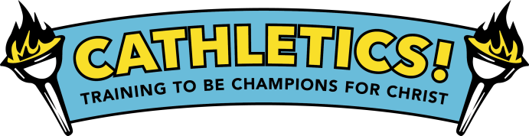
Participant Registration Form
Dates / Location:
St. Mary’s School
June 29th- July 3rd
9:00am-12:00pm

Child’s Information:
Name: _________________________________________________________________________
Sex: (circle one) M F Age: ____________ Grade current/completed: _____________
T-shirt size: (circle one) child sizes : XS S M L / adult sizes: S M L XL
Allergies or medical conditions: _____________________________________________________
Family Information:
Parents/Guardians’ Name(s): _______________________________________________________
Address: _______________________________________________________________________
Phone Numbers:
Hm: ___________________ Wk: ____________________ Cell: ______________________
Email: ___________________________________
Emergency Contact:
Name: _________________________________________________________________________
Phone: __________________________________

I understand that reasonable precautions will be taken to safeguard the health and well-being of the participants in this VBS and that I will be notified as soon as possible in the event of an emergency. In the case of sickness or an accident, I authorize and consent the VBS Team, or other associated volunteers of the VBS program to obtain medical care from a licensed physician, hospital, or medical clinic for my son/daughter in the event that myself or other legal guardian(s) cannot be reached. I hereby do release and forever discharge this Diocese, Parish and/or Organization from all manners of actions, claims which I or the child named above shall or may have for any reason, arising during my child’s attendance of the VBS.
Unless other written instruction is submitted, I also consent to allowing my child’s image to be recorded, either by photograph or video, and used during the VBS week or for future advertisement of Parish VBS programs. Any other use will require your further consent.

_________________________________________ ______________
Parent / Guardian Signature Date

Return completed form by June 15th, 2015

